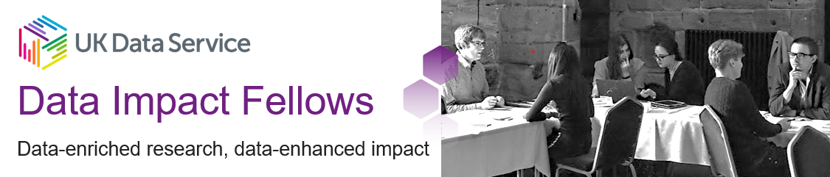

#### Are you an early career researcher in the academic or VCSE sector?

Is your research related to one of these themes:

* poverty, deprivation and the cost-of-living crisis
* housing and/or homelessness?

#### Does your research use data in the UK Data Service collection?

Would you like support to develop your ideas for creating impact from your data-enhanced work and a £2000 award to help you fund your development?

**If so, we invite you to apply for the next round of our Data Impact Fellows scheme.**

The scheme offers:

* financial support to help you develop your idea of data impact
* an opportunity to meet and network with other Fellows to share and develop ideas
* sharing your work and ideas, and opening up discussion on our [Data Impact blog](https://blog.ukdataservice.ac.uk/highlights-of-our-first-dataimpact-event-2015/)
* showcasing your work and its impact through co-creating a [case study](https://ukdataservice.ac.uk/case-studies)
* contribute to our 2023 Data Impact event

The scheme will run from 01 April 2023 to 31 March 2024.

#### Qr code Description automatically generatedHow to apply

Applications will open on 9 January 2023 and close at 23:59 on 13 March 2023. We’ll let you know whether you were successful or not by 31 March 2023.   
**Apply online at** [https://blog.ukdataservice.ac.uk/data-impact-fellows-2023/](https://blog.ukdataservice.ac.uk/?page_id=7481&preview=true) or scan the QR code.